**VIP @ Aine Ai**

**Submitted by: Aditi Chatterjee**

**PROJECT: Vanarsdel Data Analysis (Power Bi)**

This file contains screenshots of a project I did as a data science intern. This project included creating a dashboard in Power Bi for sales of Vanarsdel from 2013-2020.

1. **The Dashboard:**

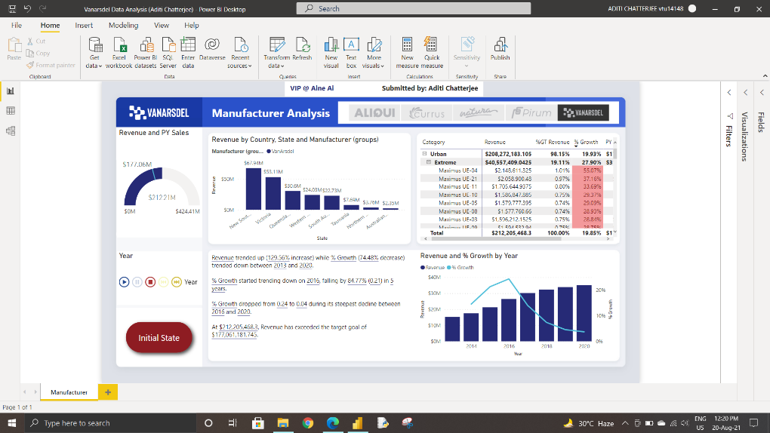

1. **Some Bookmarks:**

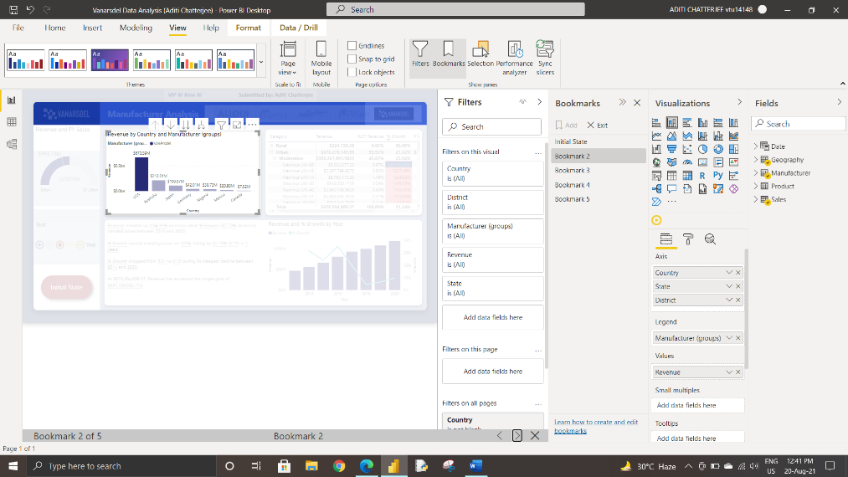

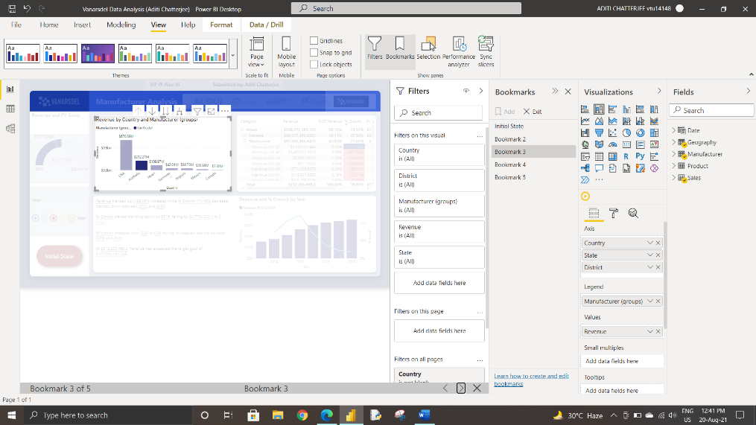

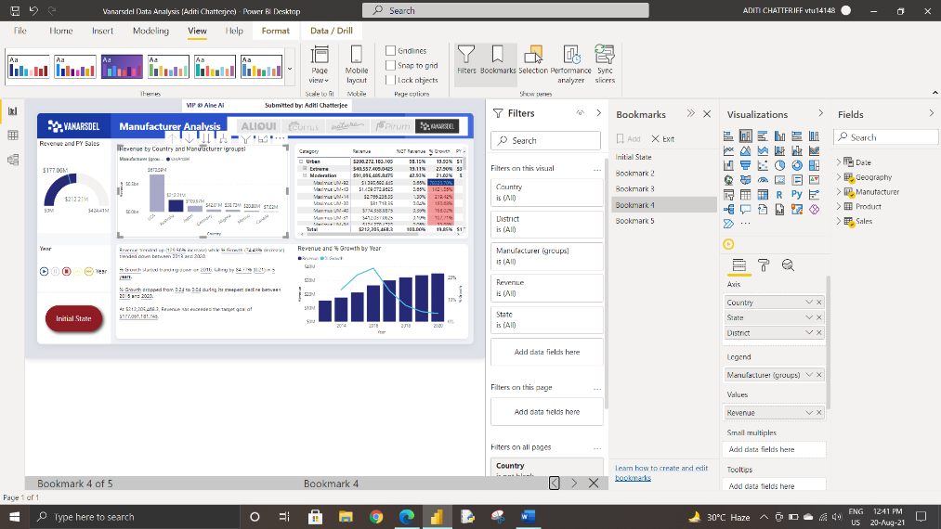

1. **Timeline Analysis:**

